Answers
Task 1
Match each sensor to the sensor name. Then match each sensor to its uses.
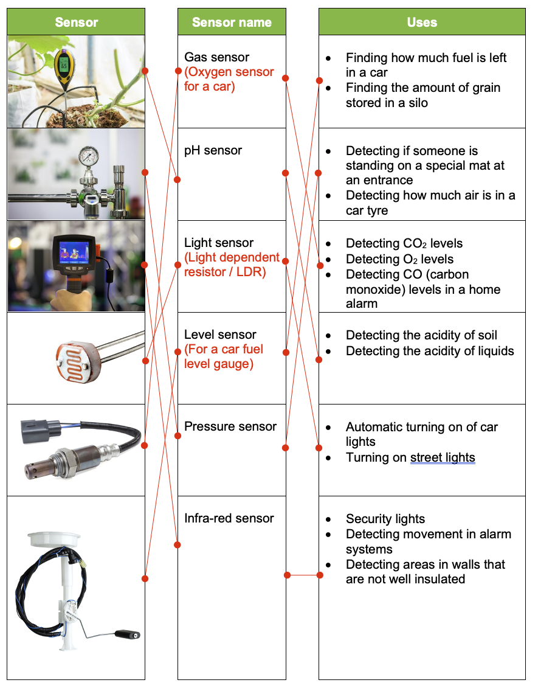

Task 2
The following sensors are covered in this topic:
- Acoustic  - Accelerometer  - Flow  - Gas  - Humidity  - Infra-red  - Level  - Light | - Magnetic field  - Moisture  - pH  - Pressure  - Proximity  - Temperature
Work with a partner to consider the most effective way to make a security alarm system for your school or home.
(a) Draw a diagram to show where different sensors are placed.

(b) Discuss which sensors are likely to work best at detecting intruders but are least likely to have false alarms. Make notes based on your discussion below.
Answers will depend on student responses. Points may include:
- Infra-red sensor – typically accurate inside the house. Likely to trigger false alarms outside the home, but suitable for security lights.
- Acoustic sensor – could detect broken glass or other noises from a forced entry.
- Light sensor – prevents security lights turning on when light.
- Pressure sensor – this could detect someone at a door by putting the sensor under a mat. However, it may be costly to install.
- Magnetic field sensor. Many security door sensors will make use of a magnet on one side of the door and a magnetic field sensor on the other. If the door is opened, the magnetic field sensor will detect the absence of the magnet. This is an effective type of sensor in security systems.

Task 3
A company makes fish tanks. Their new design has the following requirements:
- Maintain a temperature between 24ºC and 26ºC. This can be maintained using a heater and a blind that is operated by a motor.
- Show the pH level which should be between 6.8 and 7.6. An LCD display and buzzer is available for notifying the user if the pH falls outside these pH levels.
- If it is daytime, the tank will turn on an air stone which will increase the amount of oxygen in the water.
(a) State the three sensors required for the fish tank.
Temperature sensor
pH sensor
Light sensor
(b) Discuss how the sensors will work together as part of a digital control system.
The information from the sensors will be analogue. An analogue to digital convertor will be required for each sensor so that the data is converted to a digital input which will be sent to the microprocessor.
The pre-defined values will be programmed into the settings contains in a storage device, or more likely ROM contained on the microprocessor.
If the temperature is too low, the heater can be turned on. If the temperature is in the correct range the heater will be turned off and the blind opened by turning the motor. If the temperature is too hot, the blind will be lowered.
The pH level will be output on the LCD display. If it outside the given range, the buzzer will be turned on.
If the light sensor detects light over a certain threshold, it will turn on the air stone.

